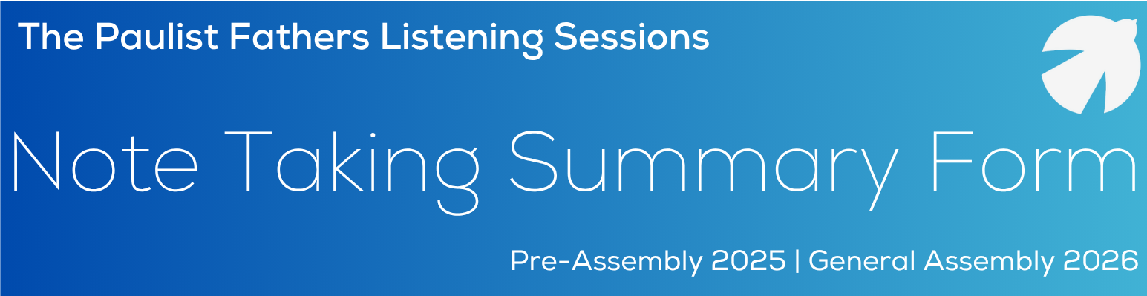
It’s important to remember that, in the synodal process, each person participating in a listening session should have the opportunity to be heard, and that true dialogue unfolds in light of what each has heard and shared.
In a listening session, every participant should first offer their personal response to the question at hand. Once everyone has shared, the group should engage in dialogue to arrive at a consensus statement in response to that question.
In larger listening sessions where participants are divided into small table groups, the same process applies: each table first engages in its own dialogue and forms a consensus statement. Then, everyone comes together in a large-group conversation to share and discuss these statements, working toward a synthesized consensus that reflects the sense of the entire gathering.
This synthesized consensus statement is what is to be reported back to the Pre-Assembly Planning Committee. These consensus statements will help the Pre-Assembly Planning Committee identify key areas for creating study groups in preparation for the Pre-Assembly meetings in October.
For note takers (scribes) to produce a good record, they should present an accurate account of what they hear during the listening session. During the small-group discussion, he/she takes notes for each of the comments made by the individuals in the small group. The scribe should also record anything he/she shared as well.
A suggested format is provided to help capture all feedback shared.
- Main Topic(s): answers the question, “what?” and describes the central idea of what the person shared
- Feedback Shared: answers the question “so what?” and explains what the person had to say about his/her main topic
If multiple people share the same sentiment, it may be helpful to include tally marks next to each comment instead of writing it repeatedly, and to help remember how many people shared the same feedback (see example on following page). *Adapted from the Archdiocese of Los Angeles
During the ﬁnal portion of each small-group discussion, the facilitator will instruct each group to review the notes taken thus far. The scribe will read the notes aloud and capture any additional group comments. The scribe will then work with the group to discuss and move toward a consensus for top idea(s) from the group and document that at the bottom of each note-taking page.

Scribe Information
Scribe Name:
Scribe Email:
Group:
(Paulist Local Assembly, parish group, Paulist Associates, etc.)

Question # 1 | The Paulist Fathers Listening Sessions 2025
Main Topic(s): | Feedback Shared:
Example: evangelization of young adults | II We have a number of young adults who come to the Sunday evening Mass
Example: evangelization of young adults | We need to recruit young adult leaders
Group Consensus Statement:
(as a group, discuss and discern the top idea(s) that represent the consensus of the group)

Question # 2 | The Paulist Fathers Listening Sessions 2025
Main Topic(s): | Feedback Shared:
Group Consensus Statement:
(as a group, discuss and discern the top idea(s) that represent the consensus of the group)

Question # 3 | The Paulist Fathers Listening Sessions 2025
Main Topic(s): | Feedback Shared:
Group Consensus Statement:
(as a group, discuss and discern the top idea(s) that represent the consensus of the group)

Question # 4 | The Paulist Fathers Listening Sessions 2025
Main Topic(s): | Feedback Shared:
Group Consensus Statement:
(as a group, discuss and discern the top idea(s) that represent the consensus of the group)

